Makefiles
So far, we have used Visual Studio to edit, compile, and run our programs. Although this makes these tasks simple, we don’t understand what the development environment is doing to complete this process. In this exercise, we will manually compile a project into an executable using a makefile and the Microsoft compliler cl.exe.
The purpose of a makefile is to manage the compilation and linking of software projects.
Recall that compiling and linking proceed as follows:
- source.c and source.h files are compiled to produce object files (.obj or .o extension). Object files contain code that is understandable to the machine.
- The linker takes all of the object files and puts them together into a single executable file. It resolves references to functions included in library files (.a or .lib). A .lib file is essentially a collection of object files.
Large software projects can have many source files. Each file needs to be compiled. Some files depend on other files as well. To manage the compiling of files, a makefile is used. The makefile is a text file (called makefile, with no file extension) that lists how files are compiled and linked and the dependencies between files. The makefile is executed by a utility called make (nmake in Microsoft world). Before looking at a makefile, it is important to understand how to compile and link a file on the command line.

Command Line Compiling and Linking
The C/C++ compiler provided by Microsoft is simply called cl.exe. It is actually an integrated compiler and linker. For example, suppose you have a source file called code.c. To compile and link this source code, the following syntax would be used:
cl code.c
The output of this file is a file called a.exe by default (or code.exe depending on compiler).
Compiler switches may also be used. For example:
-c à compile only, do not link.
-o file à Place output in a file called file.
/Wall à turn on all warnings.
Switches are case sensitive and may vary slightly depending on the compiler/linker. To compile the code.c to an object file:
cl -c code.c
Note: It is important to have the system Path variable to include the compiler, include files (headers), library files, and any other files required by the compiler/linker. The Developer Command Prompt For Visual Studio 2022 has all of these paths set for you automatically. It can be launched from the Start menu.

Creating a makefile
Consider a statistics project (has some stats functions) that contains the following files:
- mathfuncs.h (prototypes for all math functions).
- mathfuncs.c (implementations of functions).
- display.c (display results).
- stats.c (main method and test code).
The following dependency graph shows the dependencies between files when compiling and linking:
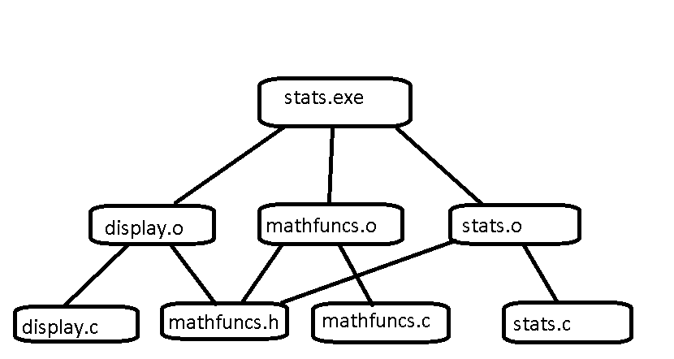
For example, display.obj is dependent on the files display.c and mathfuncs.h. The file stats.exe is dependent upon display.obj, mathfuncs.obj and stats.obj. All dependencies are highlighted in the following dependency graph:
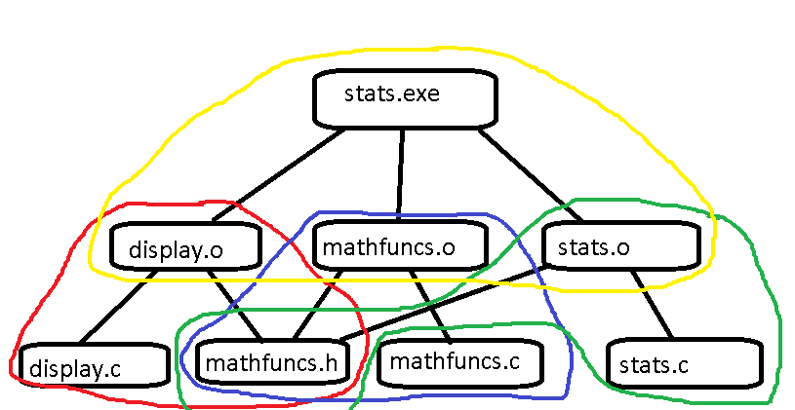
Each dependency is implemented separately as a target in the makefile.
The basic syntax used in a makefile is:
target: [dependency list]
<Tab>command to execute
Note that Tab MUST be used. You cannot indent using spaces. This is a common error and hard to catch if typing this out in a simple text editor such as Notepad.
For example, to implement the dependencies listed above, the following targets are required (color-coding not required – just used to illustrate the dependencies shown above):
statistics: display.obj mathfuncs.obj stats.obj
cl display.obj mathfuncs.obj stats.obj
display.obj: display.c mathfuncs.h
cl -c display.c
mathfuncs.obj: mathfuncs.c mathfuncs.h
cl -c mathfuncs.c
stats.obj: stats.c mathfuncs.h
cl -c stats.c
To run the makefile, use nmake as follows: From the directory where the makefile exists (and which also contains the source files), type:
nmake
Notice the order in which files are built. Since the target statistics is dependent on the other three targets, those targets are built first. The .obj files will be visible now if you view the folder where the makefile exists.
The executable is called display.exe, named by default. This can be changed by passing the switch to the linker as follows:
cl -o statistics.exe …

Rebuilding a Project
Suppose that the file stats.c has changed. Should all files be rebuilt? No, the other files do not require recompiling. nmake checks the timestamps on the files to see if they have recently changed. It only calls the required targets. In this case, targets stats.obj and statistics would be called.
Alternatively, the user can run a specified target. Suppose the file stats.c is changed and needs to be compiled for testing. nmake could be called as follows:
nmake stats.obj

Other Targets
Other targets can be added as well. For example, for administration purposes a target called clean or remove can be added:
clean:
del *.obj *.exe

Constants/Macros
Constants/macros can be used to represent things that repeat or change. or example, what if we switch compilers? We would need to replace cl with something else. Instead, we use a macro:
CC=cl
Then replace cl with $(CC)
Other variables may need to be changed as well. cl.exe uses .obj whereas gcc uses .o extension for object files. So the updated makefile might look like the following:
CC=cl
EX=obj
statistics: display.$(EX) mathfuncs.$(EX) stats.$(EX)
$(CC) -o statistics.exe display.$(EX) mathfuncs.$(EX) stats.$(EX)
display.$(EX): display.c mathfuncs.h
$(CC) -c display.c
mathfuncs.$(EX): mathfuncs.c mathfuncs.h
$(CC) -c mathfuncs.c
stats.$(EX): stats.c mathfuncs.h
$(CC) -c stats.c
clean:
del *.$(EX) *.exe
Now, if you want to compile with gcc (Unix/Linux), simply change
CC=cl to CC=gcc
And
EX=obj to EX = o

